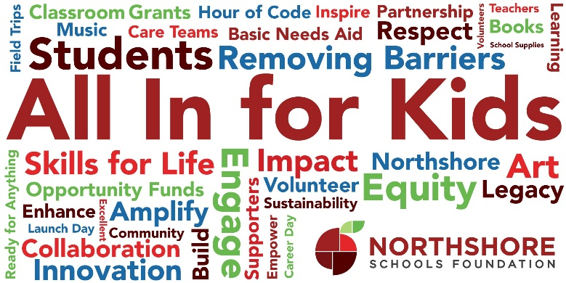

Dear Table Captain,

Covid-19 has rocked the world. But students and teachers need our help more than ever.

In 2020, we made the hard decision to cancel our annual event but this year, we are taking our event virtual and hoping to create an experience that you have come to expect from the Northshore Schools Foundation.

We want to create an experience of hope where people can come together in support of public education. Our students need us now more than ever.  We are going to be there for them.  

**Your service as a virtual room host is vital to us being able to do this.**

What you can count on this year

* Hearing personal stories on video and live from students, teachers and parents who have been impacted by the work of the Foundation this year.
* Witty emcee Jake Whittenberg (joined by Carmin) to host the event.
* Musical performances from students across the district
* An opportunity to connect with your colleagues and friends in a semiprivate setting.
* Hearing from Dr. Reid about the partnership between the district and the Foundation.

What is changing this year:

* Instead of choosing between breakfast or lunch, the entire event has moved to an afterschool, end of workday time slot 4:00 pm-5:30pm on April 8th.
* Instead of tables, we will be hosting virtual break out rooms for you and your colleagues. Rooms can host anywhere from 6-20 people. Imagine if every school had at least 2 rooms!
* Instead of a meal, you are invited to support local and purchase an appetizer tray and/or a beverage to enjoy the day of the event. Meal Pick up will be from 11-2pm at Evergreen Church on April 8. We will also have bags for you.
* A small donation to attend has been implemented, $15 a person or sponsor a table for $150. You can access a scholarship by using the word “service” in the code.

What follows are resources for you to be able to recruit guests easily and successfully to the event. Again, please do not hesitate to get in touch any time with your questions. Our Philanthropy Director, Ahna Machan, and Table Captain Lead, Jen Pirak will also be available to support you.

Thank you,

Emily Fisher, Stewardship Services Director

**Resource links and pages:**

Foundation Web Page: [www.NorthshoreSchoolsFoundation.org](http://www.northshoreschoolsfoundation.org)

Foundation Twitter: <https://twitter.com/NSFoundation1>

Foundation Instagram: <https://www.instagram.com/northshoreschoolsfoundation/>

Foundation Facebook: [https://www.facebook.com/NorthshoreSchoolsFoundation](https://www.facebook.com/NorthshoreSchoolsFoundation/)/

Foundation YouTube: <https://www.youtube.com/channel/UClGsUEqvVLqL8TfzO18TAYw>

Foundation LinkedIn: <https://www.linkedin.com/company/northshore-schools-foundation>

**Guest Registration: Eventbrite**

Virtual Event: https://allinforkids2021.eventbrite.com

**Donate:** [Northshore Schools Foundation | Kindful](https://northshoreschoolsfoundation.kindful.com/all-in-for-kids-event-2021/nsdf)

**Text 2 Give:** IMPACT to 1-425-970-8433

**Mail:** 13110 NE 177th Place #B101 PMB 103 Woodinville, WA 98072

**Contacts:**

Jen Pirak – Table Captain Lead [jgpirak@seattleradio.com](mailto:jgpirak@seattleradio.com)

Emily Fisher – Stewardship Services Director [Emily@nsdfoundation.org](mailto:Emily@nsdfoundation.org) text: 425-591-9047

Ahna Machan - Philanthropy Director [Ahna@nsdfoundation.org](mailto:Ahna@nsdfoundation.org)

Carmin Dalziel - Executive Director [Carmin@nsdfoundation.org](mailto:Carmin@nsdfoundation.org) text: 206-409-3507

**General Info:**

We are the Northshore Schools Foundation (NSDF). We serve students, teachers, and families in the Northshore School District communities of Bothell, Kenmore, and Woodinville. Our work drives resources to help students reach the promise of their potential. Since our founding in 1995, we have granted over $2.7 million to schools, teachers, and students. The Northshore community makes this possible.

We have been voted best local non-profit 501(c)(3) organization in the Best of Northshore and have received the [**Top-Rated Great Nonprofits Award**](https://greatnonprofits.org/org/northshore-schools-foundation) and Gold Participant status on Guidestar. We are best known for enriching the educational experience for students, supporting teachers, and making a meaningful contribution to public education and the community.

Our goals for this year:

* Each school/program represented by 2 virtual rooms (one staff and one parent)
* $275,000 from donors, sponsors & matching companies by 4/23/2021
* XXX number of donors during the event (TBD once attendance is finalized)

**About the Virtual Event:**

You are invited to gather in a unique virtual setting to witness some of the amazing things that happened this year. Celebrate how supporters like you made an enormous difference. Find out how the Foundation is working to be ready for whatever is next. Our students need us now more than ever.

The work we do together to inspire our educators and support our students will determine the future of our graduates and our community.

Hosted by NSD parent Jake Whittenberg, King 5 News anchor & Executive Director Carmin Dalziel, NSD Alumni this event will feature testimonies from teachers and students about learning in a Covid-19 world. You will hear first-hand what we are predicting for the future and learn how you can make a real difference to students. We cannot wait to share our story with you.

This virtual fundraising event will include interactive small group activities and whole group connection time. Your $15 donation to attend will go to work immediately to make our mission real. You will have the opportunity to add on a charcuterie tray from a local restaurant and/or beverages that you can enjoy during the event.

**What is our Why?** Your support is needed to continue the funding of many vital programs and replenish our reserves so we can be prepared and “Ready for Anything.”

**Day of event timing April 8, 2021**

11-1:00 pm Pick up Table Host Swag bag

3:30 pm – Log on to event.

3:35 pm – Say hello to the team and then go to your virtual room to get settled.

3:40 pm – Guests begin being admitted to virtual rooms.

4:00 pm – Welcome Announcement to all groups about event beginning soon.

4:08 pm ish – All groups called back to main zoom room for event.

Program

Event close

5:00pm – Break out rooms available for Networking.

5:30 pm – Event ends, rooms close

**Why Is Being A Virtual Room Host/ Table Captain So Important?**

The All in for Kids Event is the signature event for the Northshore Schools Foundation and it serves as the PRIMARY fundraiser for all the grants and funding that the Foundation provides every year. It is an opportunity to acknowledge community partners and sponsors, introduce people to the important work that is funded by the Foundation, and celebrate the impact that has been made thanks to previous donations. The Event is budgeted to raise over $275,000 this year through sponsors, individual gifts, and employer matching funds. Now that we are not meeting in person, it is more important than ever to share the cause and encourage people to give.

Your leadership as a Virtual Room Host/Table Captain is essential in creating an environment where our cause is celebrated and advanced, and a place where supporters feel valued and see that their investments make a difference.

You are the heart and hands that make this part of the process possible, and it fuels everything else we do. THANK YOU.

***The work you do for this event will benefit all students in Northshore. Thank You!***

**What Virtual Room Hosts Will Do?**

When you connect community members to our schools. you are really inviting them to act on their values.

Investment in public education promotes community, equity, and the opportunity for students to reach their potential. This is our shared mission. Contributions make programs and services available that *otherwise could not exist* across the district.

1. **Fill Your Virtual Table:**

* **Brainstorm your guest list –** Invite people who share your value of an innovative public education system that allows all students to thrive and graduate ready for success. Consider work colleagues, parents of your child’s friends or teammates, social media friends who like similar things, people whose events you have attended, family members, neighbors…
* **Why:**
* Our schools cannot do it alone
* $2,128,900 of identified funding needs right now
* We want to be ready for what is next
* Each child deserves the opportunity to succeed
* **Who:**
* WORK COLLEAGUES
* PARENTS OF YOUR CHILD’S FRIENDS
* TEAMMATES
* SOCIAL MEDIA
* FRIENDS WHO LIKE SIMILAR THINGS
* PEOPLE WHOSE EVENTS YOU HAVE ATTENDED
* FAMILY MEMBERS
* NEIGHBORS

1. **Host Your Virtual Room during the event:**

* On the day of the event, we will ask you to log on to the event by 3:30pm. We are using zoom as a platform and we will admit you to the event and then open a breakout room that will be designated for you and your guests.
* You will host the room until the beginning of the event. We will then bring you back to the main room to watch the event.

1. **After the event:**

* Thank your guests for coming and reach out to them to see if they have any questions about the Foundation.
* Provide feedback about the event to [Emily@nsdfoundation.org](mailto:Emily@nsdfoundation.org) so, we can keep building a better opportunity.

**Here is what is next:**

* Decide how you want to register for the event -$15/ $150/ “Service”.
* Decide if you want a personal group fundraising page – if so, contact Emily for details. If you have questions, do not hesitate to email me!
* Brainstorm your guest list.
* Engage online! Please like, share, and comment on our social media content. We are on Facebook, Instagram, Twitter, and Linked In. [On LinkedIn, it is especially helpful to post about corporate giving/matching.]
* Post on your own pages about why you support the Foundation and invite others to join in!
* If you cannot captain, search for another captain from your school.

**Timeline**

NOW

* Start Recruiting
* Register for the event.
* Put 4/8 at 3:30 on your calendar.
* Social Media - Like our page and event

Next week 3/1

* Invite your friends via social media.
* Social Media when you get your invitation postcard.
* Electronic Invitations - round one

When you see it - Forward press release to your friends, invite them to join you.

Week of 3/15 -

* Electronic Invitations - round two

April 2 - RSVPs are due.

April 6 - Check in with Emily confirm your room/table.

April 7 - Remind your guest via email or phone about attending.

April 8-22 – Thank your guests for attending.

**RESOURCES**

Email invitations – Don't hesitate to customize!

*Invite Template - Table captain*

*Dear Friends,*

*I want you to join me at this year’s* ***Northshore Schools Foundation’s Virtual Fundraising All In for Kids Event. - Friday, April 8 4:00pm.***

*The Northshore Schools Foundation has been hard at work for over 25 years supporting our students, and in the last 12 months, they have granted over $400,000 to support families in need and fill in the gaps that have emerged in a transitioning education system. They are a vital part of our community and provide hope and inspiration to our students and educators as they navigate this evolving educational climate.*

*Now is the time to rally around our students and teachers by supporting the Northshore Schools Foundation.*

*You are invited to gather in a unique virtual setting to witness some of the amazing things that happened this year. Celebrate how supporters like you made an enormous difference. Find out how the Foundation is working to be ready for whatever is next. Our students need us now more than ever.*

*The work we do together to inspire our educators and support our students will determine the future of our graduates and our community.*

*Hosted by NSD parent Jake Whittenberg, King 5 News anchor & Executive Director Carmin Dalziel, NSD Alumni this event will feature testimonies from teachers and students about learning in a Covid-19 world. You will hear first-hand what we are predicting for the future and learn how you can make a real difference to students. We cannot wait to share our story with you.*

*Either*

* 1. *To join my table, please register here,* [*https://allinforkids2021.eventbrite.com*](https://allinforkids2021.eventbrite.com) *and there is a question that asks “With whom would you like to enjoy this event” - I hope you will write my name in. Your $15 donation to attend will go to work immediately to make our mission real (Attending the event is free). You will have the opportunity to add on appetizer tray from a local restaurant and/or beverages that you can enjoy during the event.*
  2. *I have sponsored your space at my table, to join my table, please register here,* [*https://allinforkids2021.eventbrite.com*](https://allinforkids2021.eventbrite.com)*, click the green ticket button, and look for the blue link that asks you for a promo code – and enter- “Welcome.” During the registration process there is a question that asks “With whom would you like to enjoy this event” - I hope you will write my name. You will have the opportunity to add on an appetizer tray from a local restaurant and/or beverages that you can enjoy during the event. Or you can contact me, and I can get you registered.*
  3. *Our company has sponsored your space at my table, to join my table, please register here,* [*https://allinforkids2021.eventbrite.com*](https://allinforkids2021.eventbrite.com)*, click the green ticket button, and look for the blue link that asks you for a promo code – and enter- "Sponsor.” During the registration process there is a question that asks “With whom would you like to enjoy this event” - Please write our company’s name. You will have the opportunity to add on an appetizer tray from a local restaurant and/or beverages that you can enjoy during the event (if you are interested let us know and we may have a complimentary appetizer tray or beverage to offer you) Or you can contact me, and I can get you registered.*

*Our fundraising goal for this event is $275,000. The suggested donation at the event is $150.00. Your donation is needed to continue the funding of many vital programs and replenish our reserves so we can be prepared and “Ready for Anything.” I hope that you will consider this opportunity and that you will join me. Please let me know by March 28th if you think you can attend.*

*Thanks so much,*

*P.S. Cannot join me but still want to support the cause? You can donate here:*

***Donate:*** [*Northshore Schools Foundation | Kindful*](https://northshoreschoolsfoundation.kindful.com/all-in-for-kids-event-2021/nsdf)

***Text 2 Give:*** *IMPACT to 1-425-970-8433*

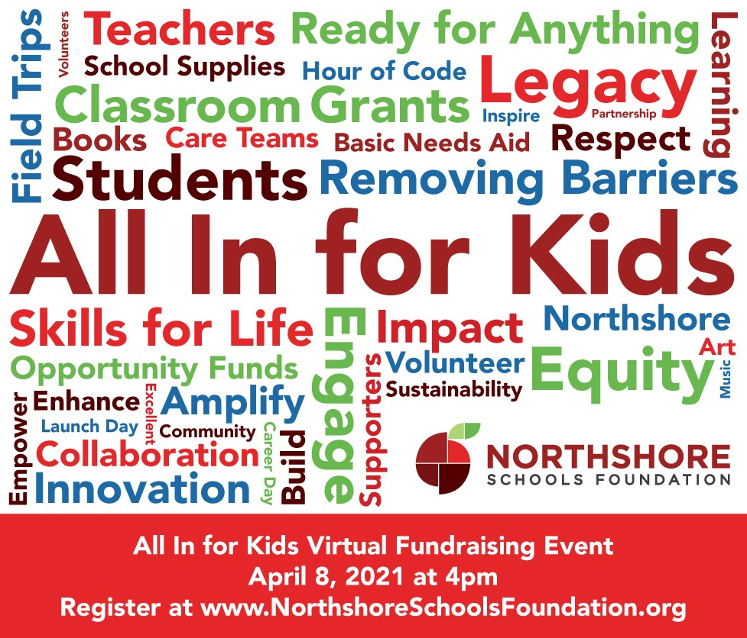

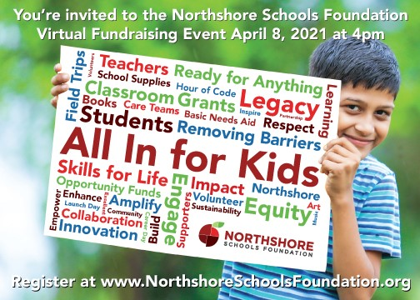

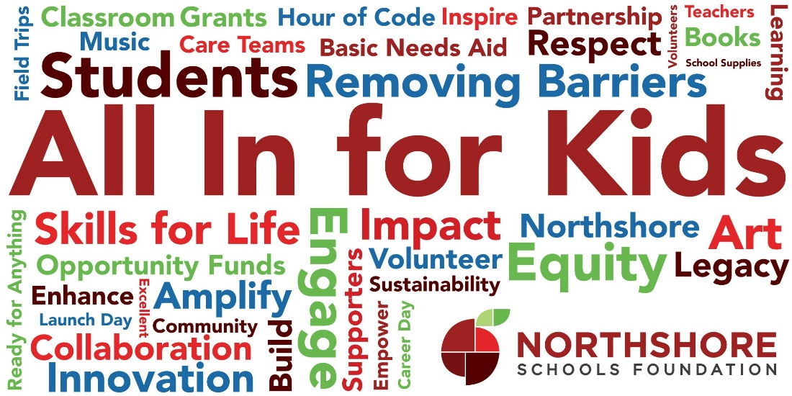

Resources to follow:

Post Cards

Virtual background

Social media meme’s

Supplemental: Annual Report Link to annual report

[2019/20 Annual Report is Available Now | Northshore Schools Foundation](https://www.northshoreschoolsfoundation.org/1920-annual-report/)

Supplemental: Why do we need the money?

Our Foundation continues to grow and stretch to meet the needs of our students. We have identified the following needs which we are diligently looking to fully fund. ***Mission Delivery Goal $2,128,900*** *Capacity Building Needs $170,000*

District & Classroom Grants Target Funds $486,000

Leadership Academies – Mid Career Professionals $24,000 annually

Curriculum Refresh Professional Development $30,000 annually

Equity & Diversity Materials Support $40,000 one time

Innovative Classroom grants $100,000 annually

Music & Art Curriculum Development $10,000 annually

NEW Schoolwide Granting Program $32,000+ annually

NEW Algebra by 8th Grade for All $250,000 annually

Removing Barriers Target Funds $1,350,000

Homeless Student Services $40,000+ annually

Basic Needs Aid $160,000 annually

Opportunity Fund $500,000 annually

Scholarships for College Credits & Competitions $35,000 annually

School Supplies $25,000 annually

Musical Instrument Acquisition $40,000 annually

Threads & Treads $20,000 annually

School Lunch Debt $30,000 annually

NEW Housing Assistance $500,000 annually

Building Skills for Life Target Funds $135,500

Career Days – Junior Highs $25,000 annually

Adult Transition Program Job Training $6,000 annually

Hour of Code/ Girls Who Code $2,500 annually

Math Olympiad/ Science Olympiad $12,000 annually

Special CTE Projects or opportunities $50,000 Startup

2019-2021 Life Skill Emphasis $15,000 annually

Launch Day – Juniors & Seniors $25,000 annually

Community Partnerships Target Funds $157,400

Beyond the Book $5,000 annually

Memberships & Affiliations $2,400 annually

NEW Innovation Fund $150,000 startup

Capacity Building Target Funds $170,000

Program & Donor Support Staff $70,000 annually

Endowment Investment $50,000 annually

Resource Mapping Project $50,000 onetime